HISTORY 139

THE HISTORY OF MODERN SOUTH ASIA

Spring 2022
TR 2:00-3:15
Genesee Hall 308
https://rochester.zoom.us/j/5852759348

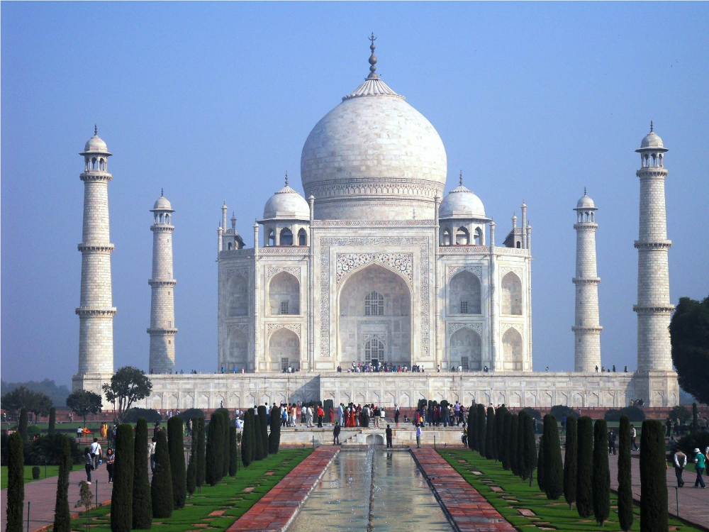
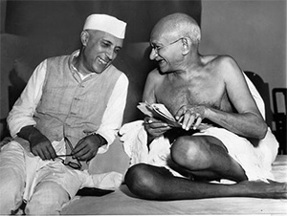

This course is an introductory survey of the modern history of India and South Asia from the age of the Mughal Empire to the present. The emphasis falls on the British colonial era and the making of the modern Indian and Pakistani nations. Our course readings will emphasize South Asia’s remarkable religious, cultural, and environmental diversity and the challenges and promises that such diversity presents to national identity and political democracy. Our format consists of a mix of informal lectures, discussions, and films as the syllabus indicates. Consistent attendance and participation, diligent reading, and thoughtful writing are essential to successful completion of the course.

Instructor:

Professor Stewart Weaver, Department of History
Rush Rhees 362
stewart.weaver@rochester.edu
Office Hours: Wednesday 2-4 pm and by appointment

Teaching Assistant:

Niharika Thakur
nthakur2@u.rochester.edu
Virtual Office Hours: Monday 2-3 pm; Thursday 11 am - 12 noon.
Course Requirements:

1. Consistent and meaningful class attendance and participation (10%)
2. Six (out of a possible eleven) short responses to the weekly reading, due on the
days of discussion, as per schedule below. Designed simply to encourage prepared discussion, these will be collected and read, but not graded. You get full credit simply for writing them responsibly. You get no credit for writing them irresponsibly (30%).
3. One 5-7 page paper due February 22 (20%)
4. One in-class debate on April 7 (20%)
5. Final essay examination, as scheduled by the registrar (20%)

NB: Except in cases of medical emergency, I will offer no early, late, make-up, or alternate final exam of any kind. Please make your travel plans accordingly.

Books: The following three books are required and available for purchase or rental at the River Campus Barnes and Noble Bookstore (or wherever). I strongly urge everyone to get all four of these books in old-fashioned printed and bound form. It will be impossible to keep up with the class without them.

Sugata Bose and Ayesha Jalal, Modern South Asia: History, Culture, Political
Economy. 3rd or 4th edition (Routledge, 2011/2017)
Rachel Fell McDermott, et. al., eds. Sources of Indian Traditions, Volume 2, 3rd edition (Columbia University Press, 2014)
E. M. Forster, A Passage to India (1924)

Statement regarding credit hours:

The College’s credit hour policy on undergraduate courses is to award 4 credit hours for courses that meet for the equivalent of 3 periods of 50 minutes each week. Students enrolled in HIST 139 are expected to devote at least one hour each week outside of class to analyzing the course readings and working on response papers and essays.

General course policies:

Students with disabilities:

The University of Rochester respects and welcomes students of all backgrounds and abilities. In the event you encounter any barrier(s) to full participation in this course due to the impact of disability, please contact the Office of Disability Resources. The access coordinators in the Office of Disability Resources can meet with you to discuss the barriers you are experiencing and explain the eligibility process for establishing academic accommodations. You can reach the Office of Disability Resources at: disability@rochester.edu; (585) 276-5075; Taylor Hall. If you have any questions or concerns, please feel free to contact me as well.

Classroom etiquette:

Please turn off cell phones or set them to a silent alert. Do not take them out in class unless instructed to do so. In the rare event you must enter late or leave class early, please let me know in advance.

Academic honesty:

All assignments and activities associated with this course must be performed in accordance with the University of Rochester’s Academic Honesty Policy. Cheating and plagiarism are serious offenses and will be treated as such. Anyone who engages in such activities will be turned over to the College Board on Academic Honesty for disciplinary action, as outlined at http://www.rochester.edu/College/honesty/. For helpful discussions of plagiarism (including subtle instances), see the American Historical Association’s “Defining Plagiarism,” https://www.historians.org/teaching-and-learning/teaching-resources-for-historians/plagiarism-curricular-materials-for-history-instructors/defining-plagiarism, and Benjamin, Student’s Guide, ch. 4, especially pp. 78-79, 81, 84-86.

Class Schedule

Jan. 13 Introduction

Week I Prologue: Ancient and Medieval India

Jan. 18 The Indus Valley Civilization

Jan. 20 The Indo-Islamic Accommodation

Reading: Bose and Jalal, Modern South Asia, chs. 1-3

Week II Mughal India

Jan. 25 The Rise and . . .

Jan. 27 Fall of the Mughal Empire

Reading: Bose and Jalal, Modern South Asia, ch. 4

Week III Indian Interlude

Feb 1 Mughal Twilight and . . .

Feb. 3 The European Intrusion (discussion)

Reading: Bose and Jalal, Modern South Asia, chs. 5-6; Sources of Indian Traditions, chapter 1, pp. 1-56.

Week IV Company Raj: 1757-1857

Feb. 8 The Making of Company Raj

Feb. 10 Orientalists and Others (discussion)

Reading: Bose and Jalal, Modern South Asia, chs. 7-8; chapter 3; Sources of Indian Traditions, chapter 2, pp. 57-96.

Week V 1857

Feb. 15 The Rising

Feb. 17 Reform and Revival: 1857-1885 (discussion)

Reading: Bose and Jalal, Modern South Asia, ch. 9; Sources of Indian Traditions, chapter 2, pp. 96-116 (Indian Rebellion) and chapter 3 (selections TBA)

Week VI Imperial Meridian: 1885-1914

Feb. 22 Enter Nationalism * FIRST PAPER DUE *

Feb. 24 Moderates and Extremists (discussion)

Reading: Bose and Jalal, Modern South Asia, chs. 10-11; Sources of Indian Traditions, chapters 4 and 5 (selections TBA).

Week VII Mahatma

March 1 [TBA]

March 3 Gandhi and his Critics (discussion)

Reading: Bose and Jalal, Modern South Asia, chs. 12-13; Sources of Indian Traditions, chapter 6 (selections TBA).

March 5 - 13: Spring Break

Week VIII Interlude: A Passage to India

March 15 Writing the Raj

March 17 A Passage to India (discussion)

Reading: E. M. Forster, A Passage to India (1924)

Week IX Indian Summer: 1919-1939

March 22 The Amritsar Massacre and . . .

March 24 the Crisis of the Colonial Order (discussion)

Reading: Bose and Jalal, Modern South Asia, chs. 13-14; Sources of Indian Traditions, chapter 7 (selections TBA)

Week X Tryst with Destiny: 1939-1947

March 29 War, Freedom, and Partition

March 31 A Tryst with Destiny (discussion)

Reading: Bose and Jalal, Modern South Asia, chs. 15-17; Sources of Indian Traditions, chapter 7 (selections TBA)

Week XI Debate: “The Partition of India was Inevitable”

April 5 In-class debate preparation

April 7 In-class debate

Week XII Post-Colonial South Asia: 1947-1971

April 12 The Making of Nations . . .

April 14 . . . and the Struggle for National Identity (discussion)

Reading: Bose and Jalal, Modern South Asia, ch. 18; Sources of Indian Traditions, chs. 8, 9, and 10 (selections TBA)

Week XIII Millennial South Asia: 1971-2010

April 19 Midnight’s Grandchildren

April 21 State and Society, Economy and Politics (discussion)

Reading: Bose and Jalal, Modern South Asia, ch. 19-20; ; Sources of Indian Traditions, chs. 8, 9, and 10 (selections TBA).

Week XIV Conclusion and Review

April 26 Review Session

Final Examination [Day, Time, Place TBA]

