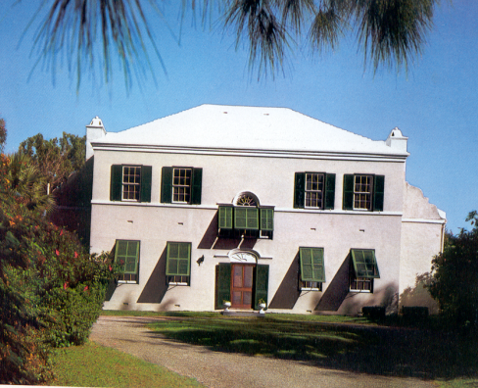
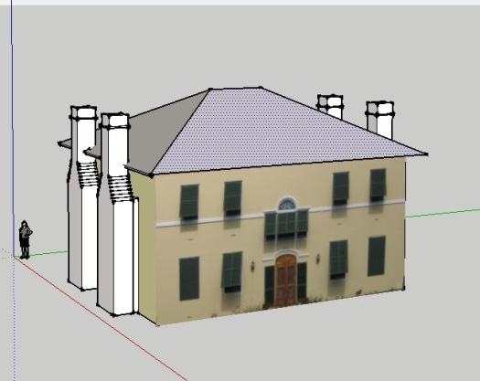
HIS 285/285W
Digital History:
Building a
Virtual St. George’s

Spring 2023 Prof. Michael Jarvis
MW 3:25-4:40 Michael.jarvis@rochester.edu
Goergen 110 & Rush Rhees 445 (DHL) Office Hours: Tu 2:00-4:00

Welcome to probably the coolest and most eclectic course you’ll probably take at the U of R, where we will explore the future of history and how to blend humanities and technology to create new ways of understanding and engaging the past. This course introduces you to historical research, digital history, and videogame design using the Virtual St. George’s Project (VSG) to practically apply technology to humanistic research and public education. Students will use a variety of historical sources and software to create a digital platform (website, videogame-based simulation, augmented reality app, interactive GIS map or story) that

You will use a variety of historical sources and software as we harness emerging technologies to educate the public about the past. In our case, we will add to an ongoing (since 2014) creation of a virtual digital model of St. George’s, Bermuda – a 415-year-old UNESCO World Heritage Site with approximately 200 properties and historic buildings. The ultimate goal of VSG is to build multi-layered 2D and 3D models of the oldest town in English America (founded 1612). Your work will require independent research on a specific St. George’s building and its property owners using manuscript and printed historical documents and digital newspaper archives, integrating this historical data into a detailed house history file and a brief “House Biography” within ArcGIS, "building" virtual 3D houses using Sketch-Up or Blender, doing field workin in St. George’s over Spring Break in St. George’s (March 4-12) by studying your houses in situ and making photogrammetry models using Agisoft Metashape, and migrating your digital constructions into Unity videogame engine. The course will end with theoretical considerations of using historic simulations and games as research and pedagogy sites and culminate with a final project in which you will design and script your own interactive digital investigation/game set in St. George’s past.

Fear not, history majors: NO PRIOR CODING EXPERIENCE IS REQUIRED – all relevant technology training will be incorporated into the course. And fear not, computer/ATHS/DMS majors: all relevant HISTORICAL RESEARCH METHODOLOGIES will also be incorporated into the course.

Evaluation: You will be based on active class participation (25%), six critical papers and research projects: an historical game/simulation critique [5%], a property research synthesis to add to the VSG Domesday [10%], a full “biography” of your house and its residents, with property deed chain [10%], a short (250-word) biosketch that you will embed in ArcGIS VSG (5%), a computer-generated 3D property model [10%], and a photogrammetry model [10%]) and a final simulation design project incorporating the semester’s collective work (25%).

Students taking HIS 285W (to satisfy an upper-level writing requirement and/or history major requirement) and HIS 485 will have the following adjusted grade weightings: class participation (20%), simulation critique (5%), research notes (10%), house biography (10%), ArcGIS biosketch (5%), computer model (5%), photogrammetry model (5%), and final simulation (25% with a slightly higher expectation of project quality). In addition, you will write a 10-12-page, double-spaced paper EITHER addressing some aspect of St. George’s history (slavery, households, family, economy, historical archaeology, gender, etc.) OR develope a theoretical and comparative appraisal of public and digital history as practiced in this Bermuda project and at least one other digital history website. The paper should also take stock of the skills you acquired while working on VSG and on how digital history might expand and improve upon how different audiences encounter or learn about history in general. This paper is due on the last day of classes (May 3) and can be resubmitted on the class’s scheduled exam date (May 10). Each submission is worth 5% of your class grade.

FIELDWORK
You are STRONGLY encouraged (but not required) to participate in active field research in St. George’s, Bermuda, over Spring Break 2023, flying down on Saturday, March 4 and returning either Saturday the 11th or Sunday the 12th. The U of R will provide housing and food for the week. We will stay on Paget Island in the Bermuda Government camp and “commute” by boat to work in St. George’s each day so you can photograph, measure, study, and explore your historic houses and the town as a whole and conduct historical research at the Bermuda Archive in Hamilton. The experience will considerably enrich your knowledge of the VSG project, “doing” digital history, and Bermudian history. This semester we will focus particularly on Black Bermudian-owned or associated properties and the multi-racial nature of the St. George’s community since its first African-descended inhabitants arrived in 1616, as well as beginning to build an ArcGIS-based AR tour of the town that will feature your own and past students’ research in this course.

While U of R can cover your in-island expenses, you are responsible for travel/airfare to and from Bermuda, which will likely range from $600-$800 RT from Rochester on our target dates. There may be needs-based travel subsidies available through the Office of Undergraduate Research; please contact me by email early in the semester (before February 3) to learn how to apply for this.

Class Participation: You are expected to attend every class, read the assigned material, and come prepared to talk about what you have read. Since history classes are by nature usually question-driven, you will be expected to think on your feet, frame historical questions, critically evaluate the works we will read, and engage with your fellow classmates. In contributing to discussion, quality is more appreciated than quantity. Be courteous and respectful to your peers. A history class is not a spectator sport: if you are silent, I will assume you are unprepared rather than brilliant but shy. Your class participation is worth twenty-five percent (25%) of your grade. Unexcused absences and poor participation will cause this grade to suffer.

TECHNOLOGY TUTORING AND CONSULTATION
This course will involve a lot of self-teaching and peer-teaching as we collectively work to build new digital educational platforms. Most of you will not be previously familiar with Metashape, SketchUp, Unity, and other software that we will use, or with the historic records relevant to your project focus. That’s OK. We have a fantastic, talented and generous staff at the Digital Scholarship Lab who will help teach this class and are available to help you design and build your projects. Blair, Josh, Lisa, Jim, and Joe can help you with documentary editing, web design and website building, coding, microcomputing, GIS, photography, GPS anchoring, Unity, AR/VR, and a bunch of other things. As you formulate a potential project, perhaps meet first with DSL Director Emily Sherwood for advice and direction. The DSL is located in Rush Rhees Second Floor, next to the Humanities Center Because we are harnessing the newest technologies, our biggest challenge will be in identifying the best emerging digital tools to use and keeping abreast of the newest software releases and technologies with which to work.

UR Writing, Speaking, and Argument Center (WSAP): Over the course of the semester while developing your reaction and research papers, you are allowed -- and very much encouraged -- to work with writing tutors and specialists in the College WSAP, located in Rush Rhees G-122. They will help you to improve your prose and organization and can serve as ideal readers/sounding boards as you develop your research projects. As a fortune cookie I once opened stated, “Good writing is clear thinking made visible.” The writing center staff can help you to achieve this ideal -- if you work with them. YOU MUST MAKE APPOINTMENTS IN ADVANCE to work with writing tutors, so plan ahead.

Credit Hours: The College’s credit hour policy on undergraduate courses is to award four credit hours for courses that meet for the equivalent of three periods of fifty minutes each week. Students enrolled in HIS 282/282W/471 are expected to devote at least one hour each week to identifying the main lines of argument in course readings, using online tutorials and software manuals to teach themselves digital techniques, conducting in depth research on their topics, and building their final projects.

Rush Rhees Research Librarians: You are also encouraged to consult UR research librarians early and often while developing your research paper. They can help you at all stages of the research project, especially in finding relevant source materials. You can contact them via the Reference Desk.

Students with disabilities: The University of Rochester respects and welcomes students of all backgrounds and abilities. In the event you encounter any barrier(s) to full participation in this course due to the impact of disability, please contact the Office of Disability Resources. The access coordinators in the Office of Disability Resources can meet with you to discuss the barriers you are experiencing and explain the eligibility process for establishing academic accommodations. You can email the ODR at disability@rochester.edu or call (585) 276-5075; Taylor Hall.

Academic honesty: All assignments and activities associated with this course must be performed in accordance with the University of Rochester's Academic Honesty Policy. Cheating and plagiarism are serious offenses and will be treated as such. Anyone who engages in such activities will be turned over to the College Board on Academic Honesty for disciplinary action, as outlined athttp://www.rochester.edu/College/honesty/. For a helpful discussion of plagiarism (including subtle instances), see the American Historical Association’s “Defining Plagiarism”.

A Note on Communication: It is your responsibility to get to class on time and to submit all your work on time or early in paper form. I check my email and phone messages regularly and usually am good about responding to correct and courteously worded missives, but don’t expect instant responses and do not assume I got your email. Informal and poorly punctuated/capitalized emails annoy me. If a truly urgent or important situation arises, try to contact me in person, relay a message via the history department, or call me my cell (585-485-9870), rather than trust email alone. Also, do not simply “disappear” if you find yourself overwhelmed or struggling: I can only work with you if I know this is happening, and an early timely intervention can do far more than damage control at semester’s end.

Readings (Selections – embedded in the Blackboard Syllabus)

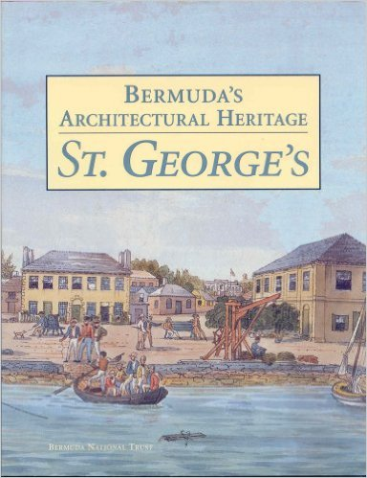
James Paul Gee, What Video Games Have to Teach us about Learning and Literacy (2007)

Michael Jarvis, Bermuda’s Architectural Heritage: St. George’s (1998) & In The Eye of All Trade: Bermuda, Bermudians, and the Maritime Atlantic World, 1680-1783 (2010)

Jane McGonigall, Reality is Broken (2011)

Seefeldt, Douglas and Thomas, III, William G., "What is Digital History? A Look at Some Exemplar Projects" (2009) http://digitalcommons.unl.edu/historyfacpub/988

Adam Chapman, Digital Games as History: How Videogames Represent the Past and Offer Access to Historical Practice (2016)
Erik Champion, Playing With the Past (2010) and Critical Gaming: Interactive History (2023)

Ian Bogost, Persuasive Games: The Expressive Power of Videogames (2007) and How To Do Things With Videogames (2011)

Web Links and Video Tutorials
PLEASE GOOGLE TO IDENTIFY THE MOST CURRENT TUTORIALS!!!

Bermuda Gazette, 1784-1900 and other digitized periodicals
http://bnl.contentdm.oclc.org/

http://www.sketchup.com/learn/videos/826
https://www.youtube.com/watch?v=z2f3DlI31-M
http://www.mastersketchup.com/sketchup-tutorials/
https://www.youtube.com/watch?v=LLV7h-WLIx0
http://www.creativebloq.com/3d-tips/blender-tutorials-1232739
https://www.youtube.com/watch?v=HiJmqidquM4

https://www.agisoft.com/support/tutorials/
https://styly.cc/tips/photogrammetry_discont_metashape/
https://www.youtube.com/watch?v=LeU_2SHwhqI
https://dinosaurpalaeo.wordpress.com/2013/10/31/photogrammetry-tutorial-1-equipment/ (12 tutorials of Photoscan for paleontology modeling of dinosaurs)
https://unity3d.com/
https://learn.unity.com/
https://gamedevacademy.org/best-unity-tutorials/ https://docs.unity3d.com/2022.2/Documentation/Manual/index.html
SCHEDULE

1/11 (W) – Introductions - Getting to know DH, VSG, and each other (a conversation with maps)

Week I – Go Play A Game

Jan. 16 (M) – MARTIN LUTHER KING DAY – No Class

Jan. 18 (W) – NO CLASS – instead, go play at least TWO different types of videogames that have some sort of historical or contemporary narrative or immersive world-building element to them (i.e., NOT Candy Crush or Pokemon Go). THE ART AND MUSIC LIBRARY in Rush Rhees (G-level) and STUDIO X in Carlsen Library have a wide selection of Xbox and PS4/5 console games, and you probably already have tons on your own phones/Switch/laptops. As or after you play, write up a 1-2 page reaction paper about why you like these games/chose them from among the thousands out there and consider HOW the game is designed to make you like it.

Week II - Digital Historical Simulations:
Video Games, Virtual Worlds, & Expanding Historical Media

What is history? What is a game? What is a historical game? How can games teach history (and how can’t they)? Why use games to explore historical subjects? What interpretive advantages do digital media have over traditional “between two covers” scholarship? What are the range of subjects that have been (or can be) investigated through games?

Jan 23 (M) Discussion of the games you played last week and these readings:
* Gee, Video Games, 1-43;
* McGonigall, Reality is Broken, 1-34, 77-94
* Bogost, Persuasive Games, preface & Ch. 1
* Seefeldt and Thomas, "What is Digital History?

FOR NEXT CLASS: visit one of the following games or DH sites below and explore it for at least five hours as a participant-observer. Take notes and write a critical evaluation paper, addressing 1) target audience, pedagogical goals, and source basis; 2) historic accuracy and effectiveness (user interface/design) in teaching and learning; 3) strengths and weaknesses/limitations of doing history with the chosen platform and subjects; 4) how the site was built (vision, funding, design and implementation team, specific hardware and software used, sustaining and updating the project); 5) personal engagement, interest, assessment of learning, and suggestions for improvement. To fully address the above, you will likely have to do additional research on the web and within project websites - perhaps even contact the designers yourself.

GAMING THE PAST (Website) http://gamingthepast.net/ - a huge archive of posts and links to historical games and discussions thereof (reviews, critiques, discussions of historical accuracy, analyses, etc.) – See esp. US History Computer Games; Global Issues Games; Games with Uncommon Characters.

Pox and the City: Edinburgh http://poxandthecity.blogspot.com/
When Rivers Were Trails When Rivers Were Trails by indianlandtenure (itch.io)
This War of Mine (Steam) http://store.steampowered.com/app/282070/
1907: City of Immigrants City of Immigrants - MissionUS (mission-us.org)
A Painted Ocean (sailing sim) A Painted Ocean by Neil Thapen (itch.io)
Reconquista: The Idol of Huaca Reconquista by hedgefield (itch.io)
Argentina ’76 Argentina '76 by Studio A. I. S. (itch.io)
141 Days in Hell (WW1) 141 Days In Hell by Hodslate (itch.io)
The Black Death (Steam) The Black Death on Steam (steampowered.com)
Playing History:The Plague (Steam) Playing History - The Plague on Steam (steampowered.com)
Her Story (Steam) Her Story on Steam (steampowered.com)

For a partial list of commercial historical games (mostly military) that can also form part of our discussion, see THIS Wikipedia page. Consider Assassin’s Creed 3, 4 (Black Flag), 5 (Unity), Odyssey, Valhalla, etc.; Red Dead Redemption II;

Jan 25 (W) – DISCUSSION of your historical videogame-play

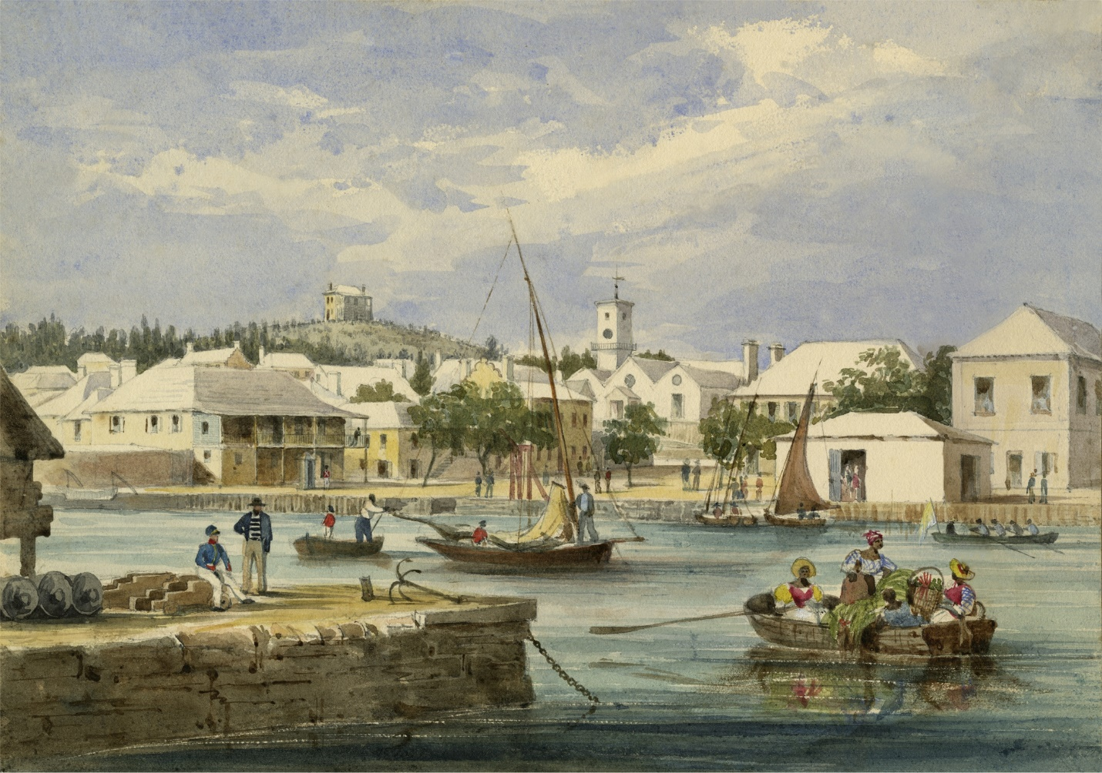

Week III - Getting to Know (and Love) St. George’s

Jan 30 (M) – FIRST PAPER DUE at start of scheduled class time (submit electronically [time-stamped] or turn in a paper copy to the History Department office)

READ: Jarvis, Bermuda’s Architectural Heritage: St. George’s (hereafter BAH: STG), ch. 1;
Jarvis, Eye of All Trade, intro, chs. 1 & 2

DISCUSSION of above: Come with notes prepared to 1. Outline the town’s key dates in terms of development and activities. 2. Discuss how architecture evolved in Bermuda and be able to identify buildings from different periods using key diagnostic characteristics used to date them.

Feb. 1 (W) Making the town yours: pick three particular buildings, families, or topics discussed in BAH: STG and Eye of All Trade that you’d like to know more about. Come to class with FIVE QUESTIONS you’d like to answer or topics you’re interested in.

Week IV – Getting Personal: Intro to Historic Research

In this week you’ll be assigned your own property in St. George’s to research, model, and otherwise work on for the rest of the semester. Most houses will have 250 to 300-year histories involving many generations of residents. They represent laboratories of historical study for social, economic, and cultural change over time. Most houses were also multiracial through the end of slavery in 1834, and this poses very real interpretive issues regarding relationships between free and enslaved members of the same household across lifetimes. St. George’s’ role as a port and a military outpost also merges local and global scales of history within your property studies.

Feb. 6 (M) – The St. George’s Domesday, House Files, and our Virtual Bermuda Archives
This class will introduce you to your property, provide you with past research done on it as a starting point, and survey the many types of primary documents to consult to add to our knowledge. These include: Deeds, Wills, Mortgages, Slave Registers, Business Records, Family Letters, Property Tax Assessments, Vestry Minutes, St. George’s Corporation Minutes, Genealogical Sources (Parish and Newspaper Births, Deaths and Marriages), probate inventories, Bermuda Government Records, Acts of Assembly, Census Records, Newspapers, Assize Court Records, etc. Most of you will consult most of these records as you work to flesh out the history of your house at its occupants across the centuries. We will also go over note-taking and proper citation methods for your

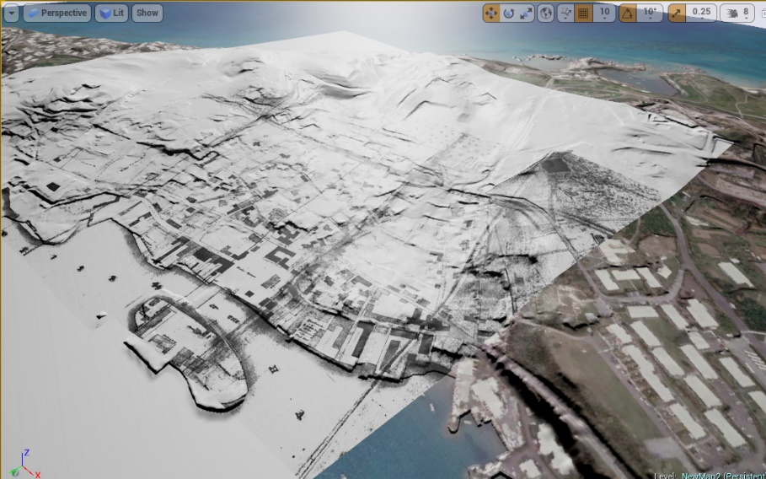
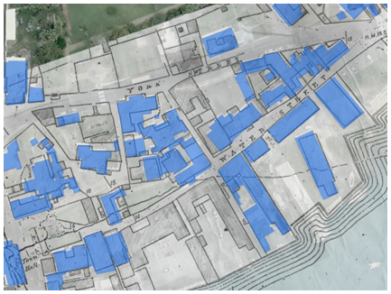
Feb. 8 (W) Location, Location, Location – Maps, ArcGIS and your households
Guest lecture/demonstration, Blair Tinker, Digital Scholarship Center GIS specialist

In this class you will individually locate your house on Google Earth, learn to take measurements and access “historic views”, consult your Bermuda National Trust Old House Survey report and individual house file, and work with ArcGIS historic maps layers to study change over time in St. George’s Built Environment. Interested students can opt to learn georeferencing of historic maps within ArcGIS.

Week V – Historical Research, Continued

Feb. 13 (M) A Wealth of Sources – continuation of historical sources, with special attention to probate inventories, and visual material, including historic sketches and photographs. Groups of students will work with 19th c. maps and sketches to identify the addresses of houses in several early 19th c. historical sketches.

Feb. 15 (W) Genealogies – introduction to genealogical sources (wills, births, deaths, marriages, newspaper notices) for generational family reconstruction and household interpretation. We will also cover name searches in the Bermuda Library’s Digital Newspapers collection and America’s Historical Newspapers series.

HIS 285W Students: meet with me in office hours or outside class individually to discuss your final paper options and inclinations.

Week VI – Texts and Contexts

Feb. 20 (M) – Troubleshooting and Work Session on House and Family Research

Feb. 22 (W) – Interpreting your research: 17^{th-} to 19th-century Bermuda.

Reading: Michael Jarvis, In The Eye of All Trade, chs. 5, 7 & Epilogue

Discussion of how your particular property residents compare with general Bermudian historical trends and social patterns. Identify where and how your “people” are typical, and how they’re distinct. Focus on different generations at different periods, and consider how residents and your property changed over time as they experienced larger Atlantic and global events and changes.

Week VII – Troubleshooting, Filling Holes, and Synthesis

Feb. 27 (M) – Communal discussion of research issues and solutions

March 1 (W) – Synthesis/ Paper #2 – Write a 8-10 page paper featuring new research on the residents of your household not well covered by the original Domesday entry. Consider using a story-teller approach as you recount these past lives. Also use a historian/analytical mode to explain why the people you’ve profiled are important and reveal key aspects of the past (social, racial, economic, cultural, gender, material culture, technology, etc.) End by considering how you might turn this historical narrative into a digital/simulation format, and what you might gain through this new media. Expanded research notes for your house and the 250-word house biosketch/deed chain are also due!

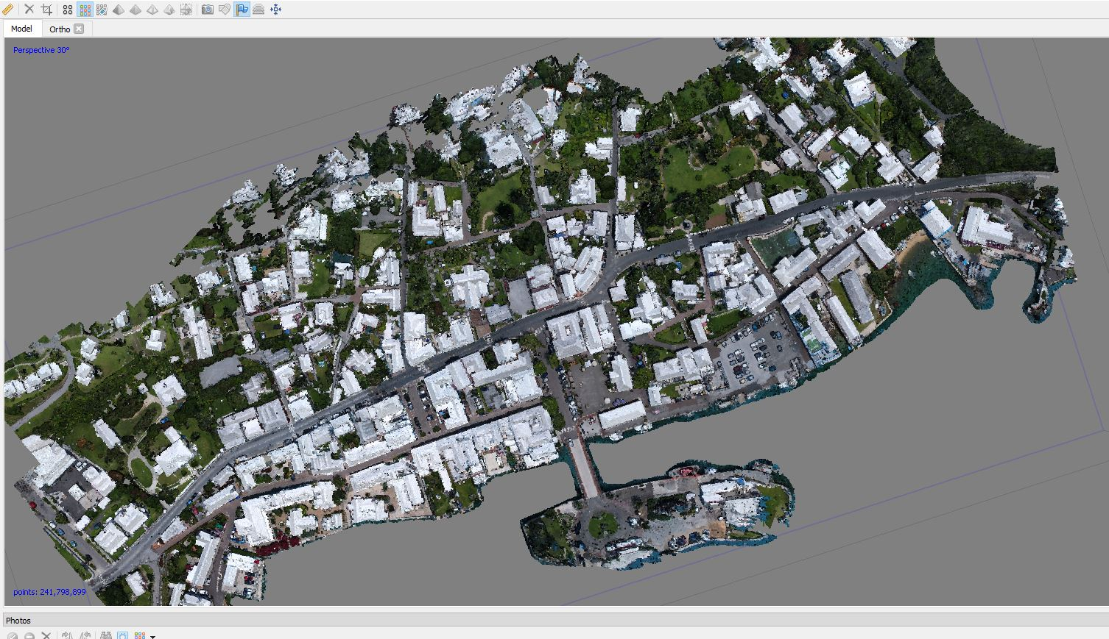
Week VIII – SPRING BREAK FIELDWORK IN ST. GEORGE’S
Schedule is tentative and will be adjusted for weather conditions

March 4 (Sat) – Arrive in Bermuda, settle in at Paget Island & Orientation Tour of St. George’s

March 5 (Sun) –Group/Individual exploration of St. George’s and Postcards from the Past “Scavenger Hunt”

March 6-9 (M-Th) Intro to photogrammetry pictures and software; Reading: Useful tips on Image Capture and Photoscan manual. Guided house recording in pairs. Possible Visits to Tucker House (1752) and Globe Hotel (1700). Continued fieldwork and/or Bermuda Archive research

March 10 (Fri) Morning: finish research/data collection. Afternoon: public presentations of your research and data collection to St. Georgians (Location TBD)

March 11 (Sat) Free Day to explore Bermuda – Dockyard, Hamilton, Aquarium/Zoo, Beaches, or just chill.

March 12 (Sun) Return to Rochester

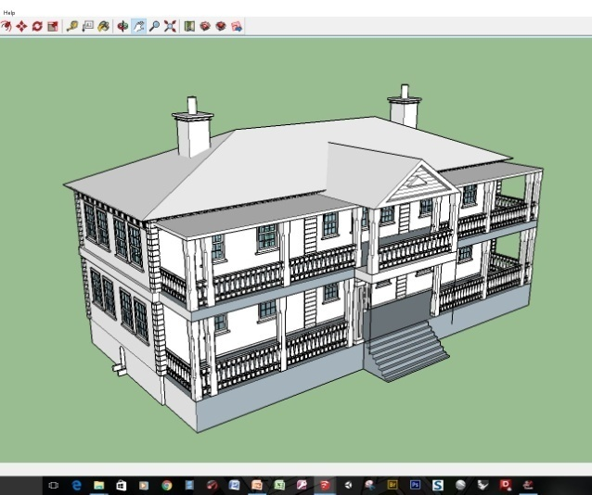
Week IX – From 2D to 3D: Building Houses and the Town

Mar 13 (M) NO CLASS – recover from Spring Break!

Mar 15 (W) Intro to SketchUp/Blender – begin 3D modeling your properties with Blair Tinker (Digital Scholar) – introduction to Sketch-Up and/or Blender for building 3D versions of your house/property to reflect physical change over time (footprint, façade, orientation, outbuildings, paint color) using evidence from historical maps, sketches, historic photographs and your own fieldwork. We will use your recordings of dimensions and ArcGIS data in the model-building process. For reconstructing historic buildings that no longer survive or are in ruinous shape, we will discuss strategies for reasonable approximations of appearance.

HIS 285W Students: Turn in a written 2-3 paragraph description of your research paper and a preliminary bibliography

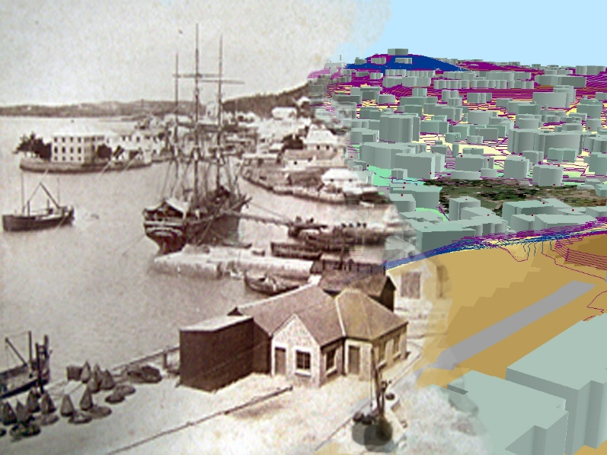
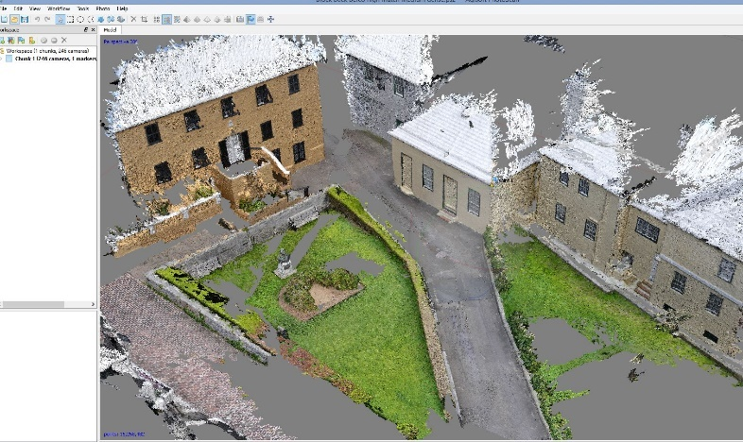
Week X –Capture From Reality 3D modeling

Mar 20 (M) & 22 (W) Work sessions on your full-resolution Metashape 3D photogrammetry models and continued work on SketchUp model creation.

Week XI & XII – Putting it All Together

Mar 27 (M) Final renders of your 3D house models (photogrammetry & digital builds) due in class. Where appropriate, prepare TWO versions of your SketchUp model: the property today and its appearance in the year 1775. In class, give a short 3-5 minute description of your house’s physical change over time as related to its residents.

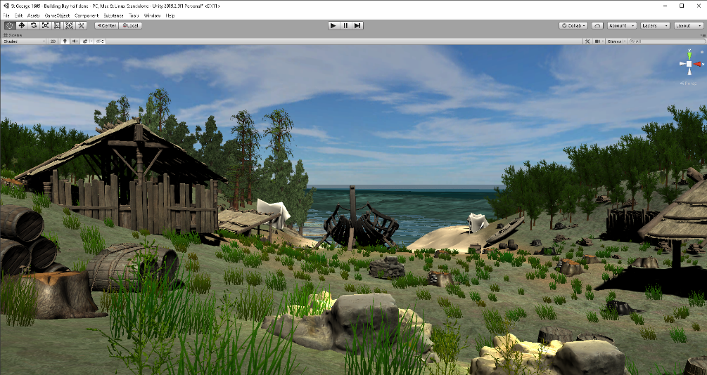
Mar 29 (W) – Unity – introduction to Unity videogame engine and creating virtual environments - Guest Presenter TBA from Studio X.

April 3 (M) & 5 (W) – Communal work sessions: converting and importing your house models into the 1775 and Modern Master VSG Unity builds.

Week XIII – Brave New Worlds and What to Do with Them

Apr 10 (M) – Games, Simulations, and Education – Discussion, Gee, Video Games, 45-143

Apr 12 (W) – The Psychology of Good Game Design – Discussion, Gee, Video Games, 145-219; McGonigall, Reality is Broken, 52-76

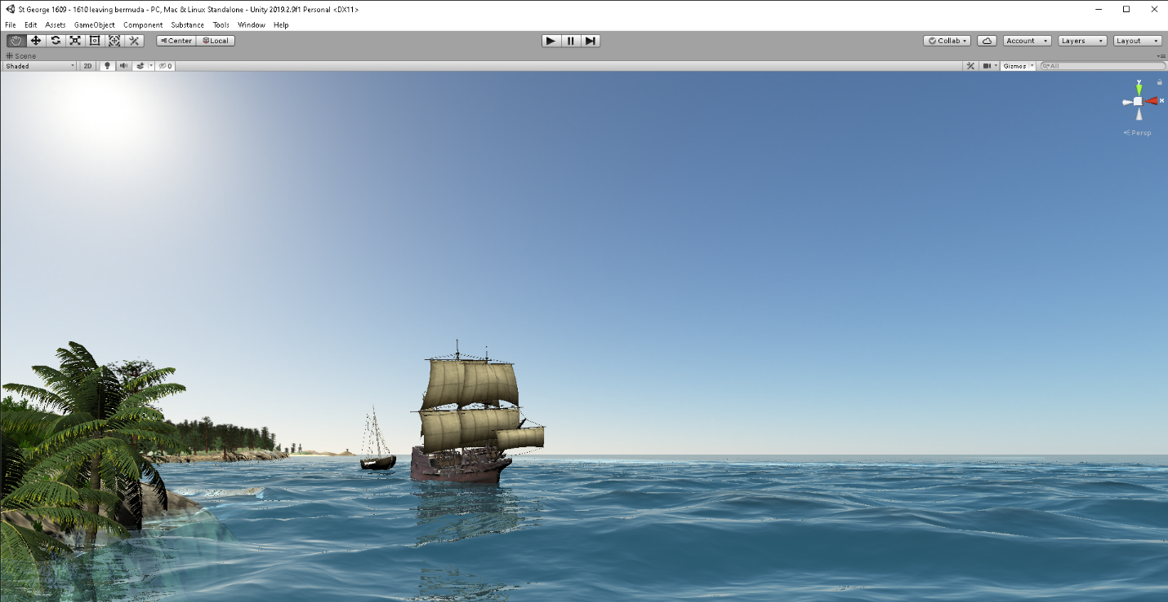

Week XIV – Your Final Mission…

Apr 17 (M) – Designing Games and simulations for Virtual St. George’s – discussion of goals and principals for your final project.

Apr 19 (W) – Communal Brainstorming session (students only)

Week XV

Apr 24 (M) & 26 (W) Class Presentations of your Historical Game ideas. Please prepare a 8-10 minute description of your game, ideally with paper/wireframe mockups, graphics, and narrative scope. Address targeted user group, game mechanics and envisioned educational outcomes.

Apr 24: HIS 285W Students: Research Paper DUE -

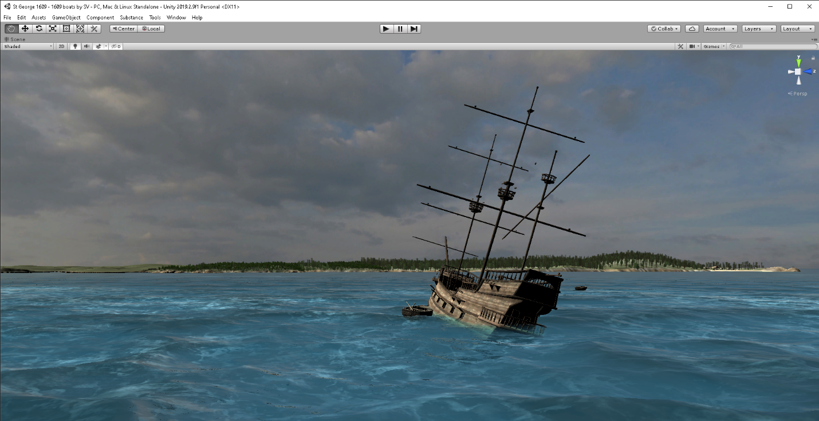
May 3 (W) Game Design Papers Due. Extra credit for having a working prototype of your game or simulation! Optional Rewrites of HIS 285W Research Papers also due.
Don't Let This Be You! Keep Working Steadily Throughout the Semester!!!

