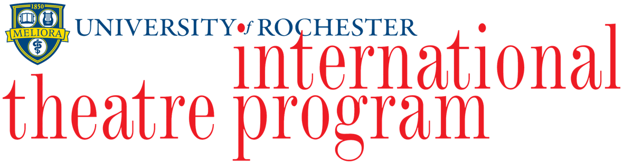

content advisory

please be aware:
loud noises, strobe lights, theatrical blood and vomit effects are used
in this production.

additionally, simulated graphic acts of self-harm and violence are depicted.
references are made
to sexual violence.

