HISTORY 226/226W

Exploration, Science, and Adventure

Spring 2023
TR 9:40-10:55
Rush Rhees 456

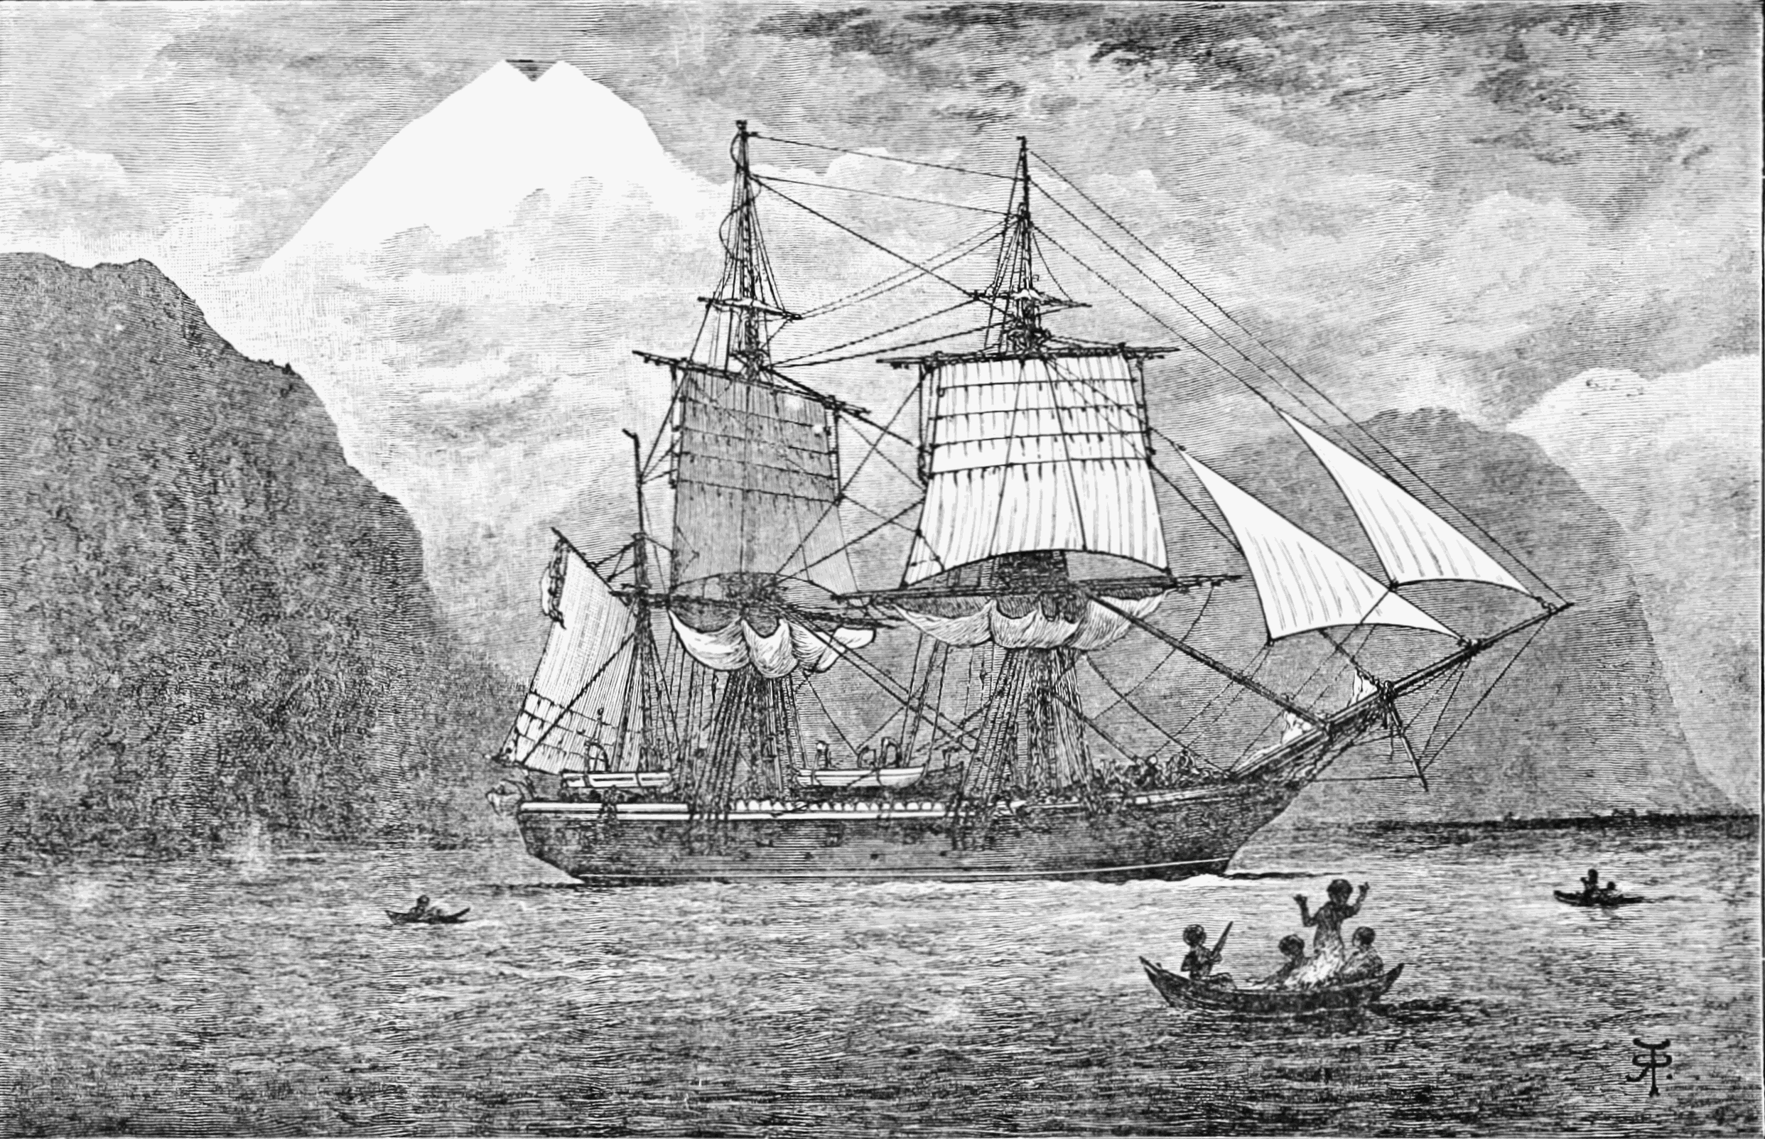

HMS Beagle in the Straits of Magellan, Monte Sarmiento, Chile

This course is a general introduction to the intersecting histories of exploration, science, and adventure from the eighteenth-century Enlightenment to the present. After a preliminary look at the idea of "exploration," what it means, and what distinguishes it from mere travel and/or adventure, we will focus each week on a discreet episode of scientific exploration, beginning with the Atlantic voyages of Edmond Halley and concluding with the Voyager missions to interstellar space. Other notable cases will include the epochal Pacific voyages of James Cook, the South American travels of Alexander von Humboldt, the transcontinental journey of Lewis and Clark, Robert Scott's fateful journey to the South Pole, and early scientific exploration and mountaineering in the Himalaya. Our emphasis throughout will be on the complex relation between exploration and science, and on the ways in which exploration has shaped for good and ill our modern, globally interconnected world.

The course meets twice a week for seventy-five minutes. Each week on Tuesday, I will present an informal lecture on a particular episode in the history of scientific exploration. Then, on Thursday, we will hold an open seminar discussion of that episode based on a selection of either primary or secondary readings (or both). Attendance at both meetings, Tuesday and Thursday is essential to satisfactory completion of the course.

Instructor:

Professor Stewart Weaver, Department of History
Rush Rhees Library 368
275-9348/315-0825
stewart.weaver@rochester.edu
Office Hours: Wednesday 2:00-4:00 and by appointment

The following books are required and available for purchase at the College Town Barnes and Noble Bookstore. They are also available inexpensively on Amazon, etc. No doubt some could be read online also, but I strongly encourage everyone to read these books the old-fashioned way, on printed and bound paper. Where assimilation and comprehension are concerned, I believe there is no substitute for this ancient (or at least medieval) practice.

Stewart Weaver, Exploration: A Very Short Introduction (ISBN 9780199946952)
Andrea Wulf, Chasing Venus (ISBN 9780307744609)
Charles Darwin, Voyage of the Beagle (ISBN 9780140432688)
Apsley Cherry-Garrard, The Worst Journey in the (ISBN 9780143039389
Dane Kennedy, ed. Reinterpreting Exploration (ISBN 9780199755332)
Jim Bell, The Interstellar Age (ISBN 9781101983898)

Note that there will be a lot of additional primary and secondary reading along the way as the syllabus indicates.

Course Requirements (226):

1. Consistent attendance and participation in class (20%)

2. Six informal response papers (30%), two by February 9,
two by March 23, and two by April 20

3. Two formal six-seven papers (50%), due March 8 and May 7.

Course Requirements (226W):

1. Consistent attendance and participation in class (20%)

2. Six informal response papers (30%), two by February 9,
two by March 23, and two by April 20

3. 12-to-15-page primary research paper (50%) consisting of the following three elements:

-- A 2-to-3-page proposal due the week after Spring Break
-- A rough draft of paper due the week of April 17-21
-- A final draft due the week of May 1-5

Statement regarding academic honesty: All students in this class will be expected to be familiar with and abide by the principles of academic honesty as laid down by the College of Arts and Science’s academic honesty policy. For the full articulation of this policy (including the consequences of its violation), see http://www.rochester.edu/college/honesty.

Statement regarding credit hours: The College’s credit hour policy on undergraduate courses is to award 4 credit hours for courses that meet for the equivalent of 3 periods of 50 minutes each week. Students enrolled in HIS 229/W are expected to devote at least one hour each week to reading and research outside of class time.

Statement regarding disability services: The University of Rochester respects and welcomes students of all backgrounds and abilities. In the event you encounter any barrier(s) to full participation in this course due to the impact of disability, please contact the Office of Disability Resources. The access coordinators in the Office of Disability Resources can meet with you to discuss the barriers you are experiencing and explain the eligibility process for establishing academic accommodations. You can reach the Office of Disability Resources at: disability@rochester.edu; (585) 276-5075.
A Note on Class Participation: This course depends on interactive lectures, presentations, class discussions, and written assignments that feed off our weekly readings. For you to learn, you need to participate consistently and stay current on all meetings and readings. Class attendance, therefore, is mandatory to your best capacity. That said, I recognize that you (or I) might need to miss one or more classes for any number of good reasons. Let me know if you need to miss a class so that we can make alternative arrangements for you to keep up with the class material.

Class Schedule

NB: This is a tentative schedule of class meetings and reading assignments as of the start of the semester. I reserve the right to make adjustments and changes as needed as we go along

Jan. 12 No Class: begin reading for discussion of January 19.

WEEK I What is Exploration?

Jan. 17 Introduction and Overture

Jan. 19 Discussion: Stewart Weaver, Exploration: A Very Short Introduction; Dane Kennedy, “Introduction,” in Kennedy, ed., Reinterpreting Exploration; Michael Robinson, “Science and Exploration,” in Kennedy, ed., Reinterpreting Exploration, ch. 1; Michael Robinson, “What is Exploration,” from “Time to the Eat the Dogs,” June 9, 2008

WEEK II The Early Enlightenment

Jan. 24 The Magnetic Voyages of Edmond Halley

Jan. 26 Discussion: Extracts from Halley’s captain’s log in J. W. Thrower, ed., The Three Voyages of Edmond Halley in the Paramore, 1698-1701 (Blackboard); Michael Reidy, et. al., Exploration and Science, ch. 1, “Navigating the Oceans” (Blackboard).

WEEK III The Voyages of Captain Cook

Jan. 31 Cook and his Times

Feb. 2 Discussion: Extracts from James Cook, The Journals (Blackboard); Andrea Wulf, Chasing Venus: The Race to Measure the Heavens, Prologue (xvii-xxiv) and Part II: Transit 176; Review Weaver, Exploration, ch. 5, “Exploration and the Enlightenment.”

WEEK V Enter Romanticism

Feb. 7 The Cosmic Vision of Alexander von Humboldt

Feb. 9 Discussion: Extracts from Alexander von Humboldt, The Personal Narrative (Blackboard); Michael Reidy, et. al. Exploration and Science, ch. 3, “Humboldt and the Rise of the Geophysical Sciences” (Blackboard); Review Weaver, Exploration, pp. 76-82.

WEEK VI Manifest Destiny

Feb. 14 Lewis and Clark and The Corps of Discovery

Feb. 16 Discussion: Extracts from The Journals of Lewis and Clark (Blackboard); Michael Reidy, et. al., Exploration and Science, ch. 5, “Scientific Exploration of a Manifest America” (Voyager); Review Weaver, “Exploration,” pp. 83-87.

WEEK VII The Darwinian Revolution

Feb. 21 Charles Darwin and the Voyage of the Beagle

Feb. 23 Discussion: Darwin, Voyage of the Beagle (pages TBA); Michael Reidy, et. al., Exploration and Science, ch. 4, “Natural History in the Nineteenth Century” (Blackboard)

WEEK VII Into the Ice

Feb. 28 John Franklin, James Clark Ross, and the Magnetic Crusade

Mar. 2 Discussion: Extracts of expeditions accounts of John Franklin and James Clark Ross, TBA; Barry Lopez, Arctic Dreams, ch. 8, “The Intent of Monks” (Blackboard); Review Weaver, Exploration, pp. 87-90.

Friday, March 3: first paper due on Blackboard by end of the day

WEEK VIII The Beginnings of Oceanography

Mar. 14 The Voyage of H.M.S. Challenger (Dan Robb)

Mar. 16 Discussion: Extracts from the official expedition narratives of H.M.S. Challenger and the journals of Wyville Thomson (Blackboard).

WEEK IX Exploration and Empire I: Himalaya and Central Asia

Mar. 21 Servants of the Map

Mar. 23 Discussion: Extracts from Joseph Hooker, Himalayan Journals; Gordon Stewart, “The Exploration of Central Asia,” in Kennedy, ed. Reinterpreting Exploration; Kapil Raj, “When human travellers become instruments: The Indo-British exploration of Central Asia in the nineteenth century,” in Marie-Noëlle Bourguet et. al. ed, Instruments, Travel, and Science (2002), 156-88 (Blackboard).

WEEK X Exploration and Empire II: Africa

Mar. 28 Geography Militant

Mar. 30 Discussion: Berny Sèbe, “The Making of British and French Legends of Exploration, 1821-1914; Felix Driver, Geography Militant: Cultures of Exploration and Empire, ch. 4, “Missionary of Science: David Livingstone and the Exploration of Africa” (Blackboard)

WEEK XI The “Heroic Age” of Exploration

Apr. 4 Scott, Shackleton, and “The Race to the Pole”

Apr. 6 Discussion: Apsley Cherry-Garrard, The Worst Journey in the World, pgs. TBA; Stephanie Barczewski, “The Historiography of Antarctic Exploration,” in Kennedy, ed. Reinterpreting Exploration

WEEK XII The Sea, The Sea

Apr. 11 Into the Deep

Apr. 13 Discussion: Michael Reidy, et. al., Exploration and Science, ch. 7 “Human Exploration Under the Sea” (Blackboard)

WEEK XIII Cosmos

Apr. 18 “To Boldly Go . . .”

Apr. 20 Discussion: Jim Bell, The Interstellar Age: Inside the Forty-Year Voyager Mission,

WEEK XIV Conclusion

Apr. 25 Final Frontiers . . .

Monday, May 1: second paper due on Blackboard by the end of the day

The land on which the University of Rochester River Campus sits is within the historic homeland of the Seneca Nation, a member of the Haudenosaunee Six Nations Confederacy. It is covered by the 1794 Treaty of Canandaigua, between the United States Government and the Six Nations Confederacy, which affirmed Haudenosaunee land rights and sovereignty in the State of New York. Today, this region is still the home to the Haudenosaunee people, and we are grateful for the opportunity to live, work, and share ideas in this territory

