## Autocatalytic Reactions, Self-Replication and Fractals

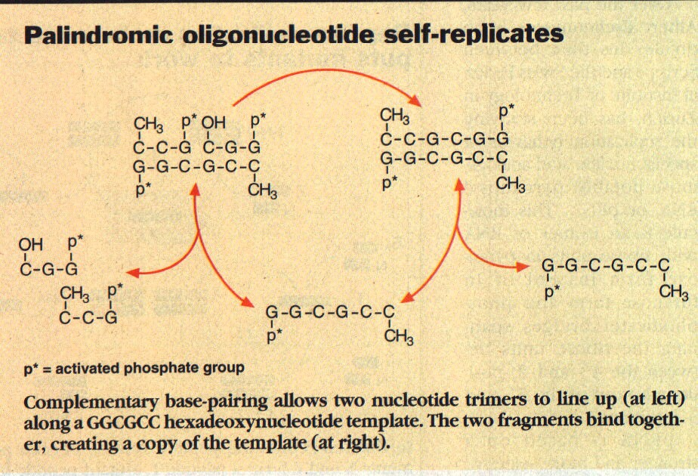S*elf-replication* is an important concept for the description of the temporal evolution of the Universe and its subsystems, including the propagation of known life forms. An example is illustrated in Fig. 1 for the cyclic (*auto-catalytic*) self-replication of a nucleotide (Wilson 1998) from two nucleotide trimers. This process relies on *complementary Watson-Crick base pairing*. Here, the purine-base guanine bonds (via a hydrogen) with the pyrimidine-base cytosine. As a result, the two initial fragments on the left of Fig. 1 line up in a certain way with the nucleotide template and, on the right-hand side, reproduce the template and a complementary copy of the template. Since the template is palindromic (left-right self-complementary), the template is copied in the auto-catalytic process. More general auto- and cross-catalytic self-replication processes are illustrated in Fig. 2 (Wilson 1998).

**Figure 1:** Self-Replication by Template

Figure Error! No text of specified style in document.‑: Example of Self-Replication

Figure Error! No text of specified style in document.‑: Molecular Self-Replication by Template

The effect of self-replication is two-fold: Without the catalytic action of a template, the reactants would collide randomly and form the template in a very small number of cases, when they are aligned just right. The template induces this alignment, such that almost all three-body collisions between the catalytic template and the other reactants lead to a replication of the template. The second aspect is that the number of templates grows exponentially in the process, such that soon no other products can be formed with sizable yield.

Figure 2: Self-replication schemes through different modes of catalysis.

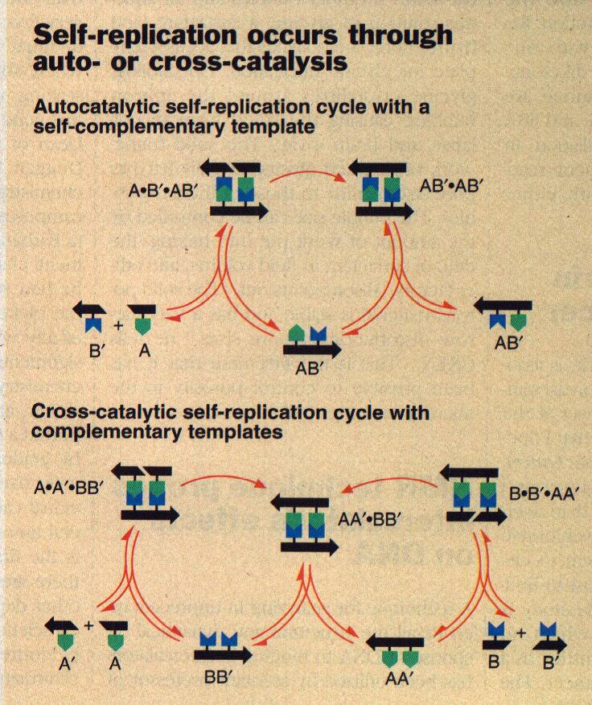

A somewhat less specific, replication-like principle appears to be important even for the formation and decay of stars. The influence that atomic and molecular electronic structure has on the growth of crystals is somewhat akin to the ***function and behavior of genes in self-replication and in steering the replication of physical form of organisms***. Self-replication can be a deterministic (orderly) or a partially or totally random/chaotic (statistical) process. It is useful to consider first the essentials of a very simple replication process and then to determine the conditions for orderly or chaotic behavior. In the following, a self-replicating process of a simple geometrical is considered, to show that complex structures of are formed in the process that reflect the particular symmetry of the parent entity.

In simple cases, one is able to represent associated rules for replication mathematically by a function ***G****,* such that, if object ***p*** is the starting point, the “parent”, then the descendant ***c*** *=* ***G****(****p****)* is a copy of ***p***, i.e., the “child” of ***p***. Likewise, ***e = G(c)=G*[*(p)*]**is the copy of ***c*** or the “grand-child” of ***p***. In a similar fashion, generation upon generation can be created by iterative application of the function ***G*** on a given ***start object***, say *x0,*

*xn* *=* ***G****(xn-1) =* ***G***[***G****(xn-2)*] = ***G***{***G***[***G****(xn-3)*]} *=* ***G*** *n*(*x0*) (51)

These functions ***G*** are examples of ***iterative maps*** discussed in previous sections***.*** They produce self-similar structures, structures that look the same on different length scales.

One of the simplest examples of such a map, illustrating a schematic replication process is the ***Sierpinski gasket***. Figure 3 shows three successive generations of triangles with increasing internal structure. The starting object *x0* is an equilateral, filled triangle, with a 90*o* angle at the top and two equal sides of length ***r0 = r =1***(in some units). This shape corresponds to half of a square, cut along its diagonal. The triangle has a filled area of ***A0 = A = ½ r2,*** half the area of the full square.

***Sierpinski Gasket***

Figure 3: Construction of Sierpinski Gasket by successive self-replication

In the replication process, one (inverted) triangle of half the total height is removed from the center of this filled triangle. Then, the daughter object is scaled up in size by a factor of *2*. In this fashion, the original triangle has produced two descendants and reproduced itself, as there are now *3* triangles of the original size and consistency. However, these triangles are now grouped together to produce another equilateral triangle with side length of ***r1 = 2r*** and (filled) area of ***A1 = (3/2) r 2 = 3A***. One may also consider the group of new triangles as the descendent of the parent, which has disappeared in the process.

***r***

If this process continues, in each reproduction, the original (solid) triangle triplicates (Alternatively, it may divide into three smaller ones, which then grow back to original size). Each time, the combined new structure is a triangle with double the side length of the previous structure. For example, the triangle of the third generation has a side length of ***r2 = 2r1*** and a filled area of ***A2 = (9/2)r2=3A1***. It also has holes of a total area of ***Atot ­­-A2****=* [***8-9/2***]***r2***.In summary, in each step, the side length increases by a factor of *2,* such that ***rn = 2n r***, and the filled area increases by a factor of three, such that ***An= 3n A0 = (3n/2)r2***.

One observes that, in each Sierpinski replication, the descendant (large) triangle has less areal density than the parent. One defines this density conveniently as the filled area divided by the total area occupied by the object,

 (52)

The start object has density ***0 = 1*** in some units, the first descendant has a density of

 (53)

The next descendant has a density of

*      *  (54)

This trend continues, and ***each following generation has only ¾ of the areal density of the preceding generation***:

 (55)

Such a correlation between size (*r*) of an object in a given family and its density (**), as plotted in the graph, is unexpected. Normally, objects have a density ** that does not depend on its size *A*. For example, a steel ball of 1cm diameter has the same density as one with a 1-m diameter.

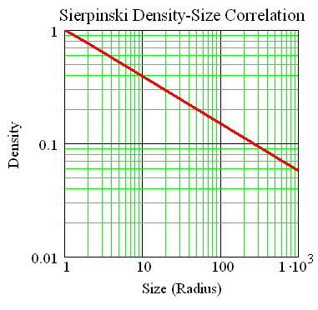

Figure 4: Density-size correlation for Sierpinski-type fractal object.

Figure 30:   
MathCad: Ro_r_Powerlaw.mcd

For objects such as the Sierpinski gasket, however, the density follows a power law. This becomes obvious when one plots the density *n* versus the side length *rn* for each generation. A log-log plot gives a linear relation, as seen on the graph (see derivation),

 (56a)

where *c* and ** are constants. This is a power law behavior of the density,

 (56b)

where the index *n* has been dropped. The dimensional coefficient ** can be obtained easily from a differentiation of the function in Equ. 56a:

*          *  (57)

In the case of the Sierpinski gasket, the coefficient turns out to be

 (58)

It is related to the ***fractal dimension df*** of the object by

 (59)

and hence

  (60)

For normal objects, the quantity *df* is an integer, e.g., *df =2* for 2-dimensional objects, and *df =3* for 3-dimensional objects. However, for fractal objects such as the ***Sierpinski gasket, this dimension is a fraction, here df = 1.58496****.* Therefore, the name ***fractal*** has been adopted for such objects. The gasket is an object somewhat between a line and a two-dimensional triangle. Other examples of fractal objects are the system of blood vessels in the human body, the coast lines of islands, the surface of aggregate clusters, among many others.

The above example of a replication process appears to be rather deterministic, and it is not obvious, if and how ***such structures and replication processes can be simulated in random statistical processes***. As will be explained, this is indeed possible. The processes that generate complex structures such as the Sierpinski gasket and other fractal objects can be generated in statistical processes, subject only to a minimum of very simple laws or rules. The ***rules of self-replication in simple systems*** will therefore be discussed next.

Mathematically, one would attempt to describe the configuration of a system by an ensemble of points or vectors in the ***configuration space***. For example, a two-dimensional rectangle is defined by the coordinates of its four corner points. Different shapes of a system are obtained by transformations in this multi-dimensional vector space {}. Growth and replication of the system is accomplished by successive (***iterative) application of such transformations***, i.e., by iterations. Translation, rotation, reflection, shearing, etc. are transformations of vector spaces with obvious geometrical meaning. Linear combinations of such transformations,

 (61)

where ** and ** are constant factors, belong again to the same class of transformations. This class has been named (*self-*) ***affine linear transformations***. The effects of the various types of affine transformations on simple two-dimensional objects can be explored with the code Affine_Transforms.mcd. The following will only consider a two-dimensional configuration vector space, i.e., vectors of the form

 (62)

and affine transformations can be represented by a *2x2* matrix ***R*** representing rotation etc., plus an additive vector  representing translation:

 (63)

One can treat the above transformation as a two-dimensional map and consider the iterations  = *G(G(G……..())) = G n()*. For example, Fig. 31 {Sierpinski_Iter.mcd}, which has been generated with the *MATHCAD* software, illustrates the development of the two components of the vectors *n* under the iterative map





 (64)

starting from the initial vector . Obviously in each iteration the transformation reduces the length of the vector by a factor of *2* and translates it into the "0"-direction. As a result, the further away from its origin an object is in the sequence, the "***younger***" it is, and the smaller its dimension. This is a property similar to the corresponding correlation for growing organisms such as trees or other plants.

**Figure 5:** Iterates of ½-self-replicate map

The laws of propagation (replication of the basic pattern) by iteration, from generation to generation, are governed by the elements of the affine transformation, the "genes". In a complex system, there may not only be one single important gene, but ***several genes can contribute in competition*** and together determine the propagation of an intrinsic pattern. Accordingly, one considers iterations using ***competitions between different transformations*** with in general different ***statistical weights*** (relative probabilities).

Here, statistical weights means random decisions with ***on average predetermined outcomes***. For example, an unbiased, even-handed decision between two alternatives can be arrived at by flipping a coin. Although every flip of the coin is uncertain, the procedure, if repeated a large number of times, will give ***on average*** 50% "yes" and 50% "no" decisions. Figure 6 below illustrates the outcomes of *i* = *200* unbiased decisions, on the left, and *i = 200* positively biased (80% "yes") decisions, on the right. Here, positive outcomes are indicated by 2 (= "yes") and negative by 1 (= "no"). The calculations were done with a simple *MATHCAD* code (Rand_Decisions.mcd), based on a ***random-number generator simulating statistical uncertainty*** (chance) in a specified range [***a***,***b***] of real numbers (RandNumbGen.mcd). Subdividing the interval [***a***,***b***] into *N* different subintervals of lengths *i = bi - ai*, these subintervals will be hit by the random-number generator randomly, but on average in proportions (probabilities) of *1: 2: 3: 4:.. N.* This procedure represents a simple method for assigning different statistical probabilities (see Tutorial Moments).





Figure 6: Random decisions with equal and different weights

An example of a ***random biased application*** of *3* genetic rules to a replication process, corresponding to the transformations *R = A, B,* and *C*, is given in Fig. 33 of the self-similar Sierpinski gasket on the left. Here, the *3* transformations are all of the form of Equ. 64, differing only by the additive vector. The iterations use the transformations *A, B,* and *C* randomly, but with average weights of *3:3:4*

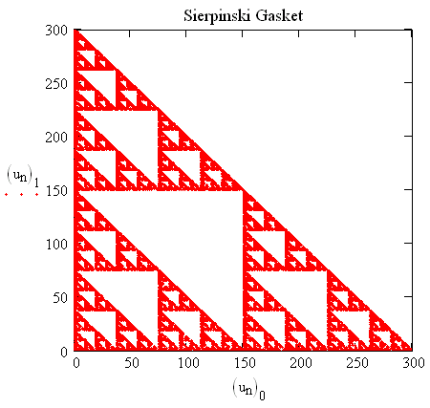 (Sierpinski_Iter.mcd). This result of a statistical replication process is very similar to the schematic figure of the Sierpinski gasket drawn earlier.

Many of the combinations that one can form of a given set of affine transformations do not lead to particularly interesting patterns. On the other hand, it seems significant that it is often possible to represent the complex growth processes in nature by random, possibly biased, combinations of very few and simple rules for replication (gene functions). One obtains mathematical representations of these gene functions empirically by analyzing the geometrical forms occurring in nature.

Figure 7: Random generation of Sierpinski Gasket with statistical weights 3:3:4.

An example of a simulation of a very complex, intricate natural pattern in very simple statistical simulations (iterations) is illustrated by the “fractal” tree in Fig. 8. It was generated mathematically by iteration from an arbitrary starting point, switching between *6* different “gene” maps in biased random fashion. The mathematical details can be gathered from the *MATHCAD* code (click to activate) Tree_Iter.mcd.

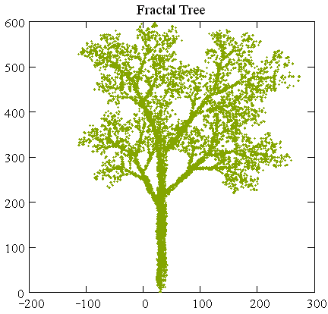

Figure 8: Fractal tree generated by a 3-dimensional replicating map.